Revision for Test 4 2019
Question 1 (4 marks)
Demonstrate your understanding of the “limiting chord process” to evaluate the following derivative.
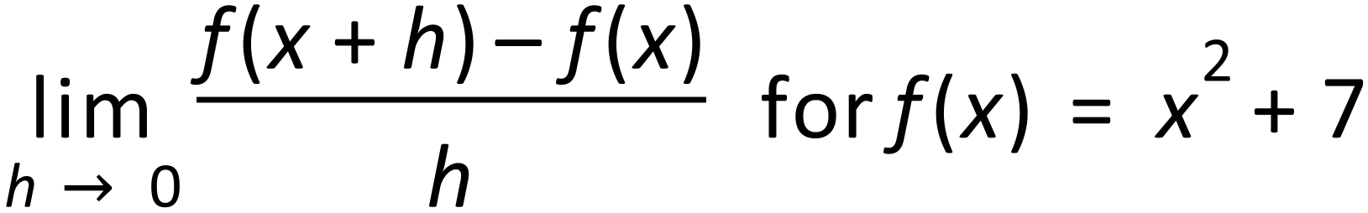
Question 2 (2, 1, 1, 2 = 6 marks)

(a) Determine $f'(x)$ when $f\left(x\right)={\left(x-5\right)}^{2}$. (2 marks)

(b) Simplify

(i) $\frac{d}{dx}\left(5x^{2}-4x+3\right)$. (1 mark)

(ii) $\lim_{h→0}{\frac{{\left(x+h\right)}^{4}-x^{4}}{h}}$. (1 mark)

(c) Calculate the gradient of the curve $y=2x^{5}-3x^{4}$ where $x=-1$. (2 marks)

Question 3 (6 marks)
Use Calculus techniques to determine the nature and location of any stationary point/s and sketch the curve 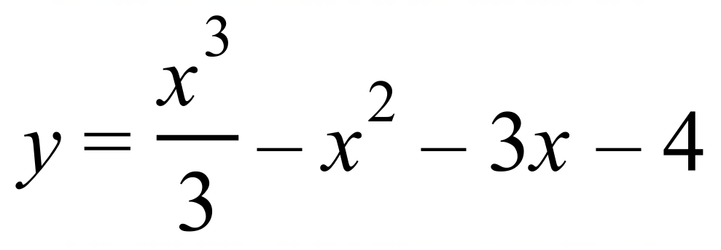 .
Note: Estimate the x-intercepts as they will not be marked.

Question 4 (2, 2 = 4 marks)
Find the antiderivative of the following. Do not simplify your answer.
a) | 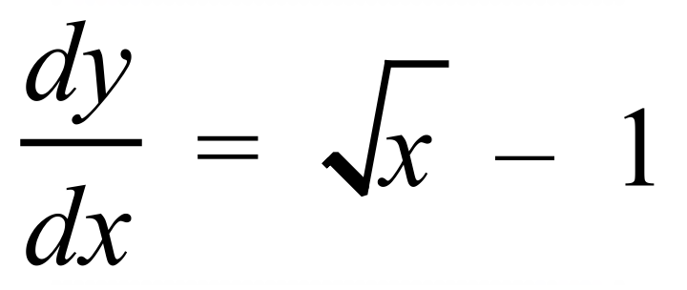
b) | 